 | RUSA Member #: Pending  Last Name:  First Name:  Address:  Brevet medals can be ordered online at www.rusa.org.  Rider’s signature at the FINISH:  The ride was done in: _______ hours _______ minutes  Organizer’s signature:  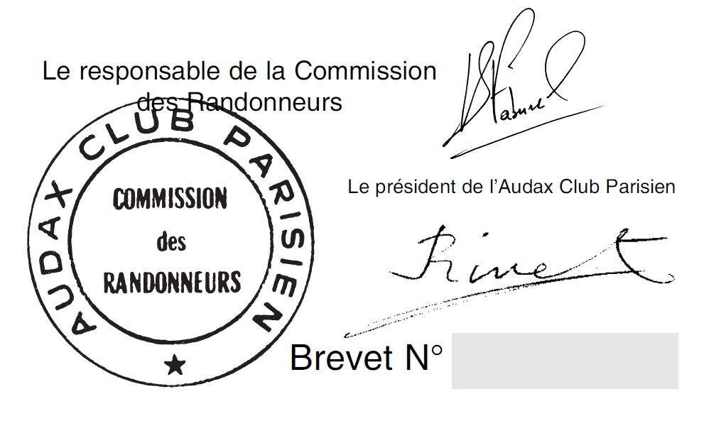  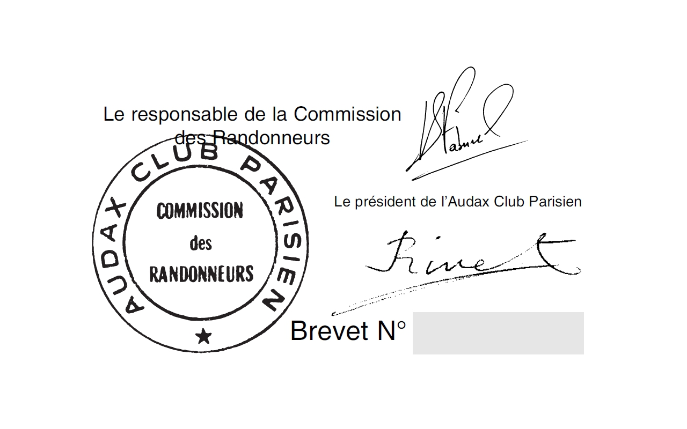  Emergency Contact Name:  Emergency Contact Phone: |  |  | Brevet de Randonneurs Mondiaux  Randonnée of KM  Organized by:  Club Name:  Date:  Location:  VERIFIED AND VALIDATED EXCLUSIVELY  BY  L’AUDAX CLUB PARISIEN
 | RUSA Member #: Pending  Last Name:  First Name:  Address:  Brevet medals can be ordered online at www.rusa.org.  Rider’s signature at the FINISH:  The ride was done in: _______ hours _______ minutes  Organizer’s signature:  Emergency Contact Name:  Emergency Contact Phone: |  |  | Brevet de Randonneurs Mondiaux  Randonnée of KM  Organized by:  Club Name:  Date:  Location:  VERIFIED AND VALIDATED EXCLUSIVELY  BY  L’AUDAX CLUB PARISIEN
Checkpoint  Address  Open/Close  Distance |  | Time:  (24 hour format) |  |  | Checkpoint  Address  Open/Close  Distance | Arrival Time:  (24 hour format)
Checkpoint  Address  Open/Close  Distance |  | Arrival Time:  (24 hour format) |  |  | Checkpoint  Address  Open/Close  Distance | Arrival Time:  (24 hour format)
Checkpoint  Address  Open/Close  Distance |  | Arrival Time:  (24 hour format) |  |  | Checkpoint  Address  Open/Close  Distance | Arrival Time:  (24 hour format)
Checkpoint  Address  Open/Close  Distance |  | Arrival Time:  (24 hour format) |  |  | Checkpoint  Address  Open/Close  Distance | Arrival Time:  (24 hour format)
Checkpoint  Address  Open/Close  Distance |  | Arrival Time:  (24 hour format) |  |  | Checkpoint  Address  Open/Close  Distance | Arrival Time:  (24 hour format)
Checkpoint  Address  Open/Close  Distance |  | Time:  (24 hour format) |  |  | Checkpoint  Address  Open/Close  Distance | Arrival Time:  (24 hour format)
Checkpoint  Address  Open/Close  Distance |  | Arrival Time:  (24 hour format) |  |  | Checkpoint  Address  Open/Close  Distance | Arrival Time:  (24 hour format)
Checkpoint  Address  Open/Close  Distance |  | Arrival Time:  (24 hour format) |  |  | Checkpoint  Address  Open/Close  Distance | Arrival Time:  (24 hour format)
Checkpoint  Address  Open/Close  Distance |  | Arrival Time:  (24 hour format) |  |  | Checkpoint  Address  Open/Close  Distance | Arrival Time:  (24 hour format)
Checkpoint  Address  Open/Close  Distance |  | Arrival Time:  (24 hour format) |  |  | Checkpoint  Address  Open/Close  Distance | Arrival Time:  (24 hour format)

